20160325
# Here is a way to disable multiple alert from failure device.
# This is very usefull option at all!
#
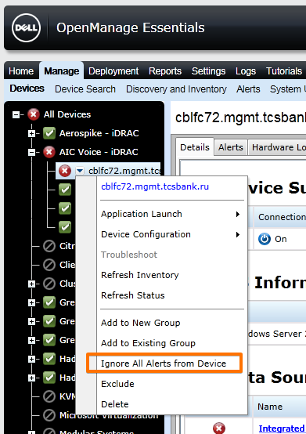

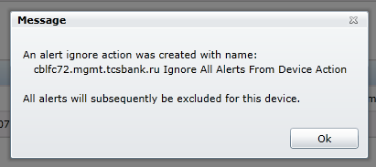

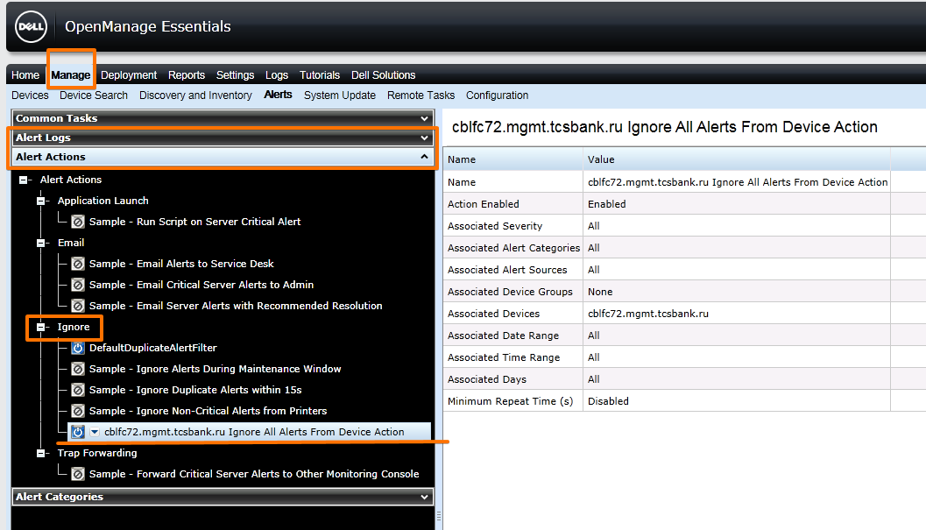

#
# We can use “Edit” option to define dates between wich these alerts will be disabled.
# This way we will not forget to turn on receiving alerts from this host.
# I suppose, that the failure on this server will be fixed before defined date period expired.
#
